 Name: ___________________________________

**UNIT 3 PRACTICAL EXAM**

**47 Marks**

**Materials: Calculator and Formulae and Data Booklet**

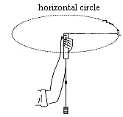**Question One (6 Marks)**

Three students were investigation circular motion in a similar manner to the investigation you carried out earlier this year. A string passes through a hollow tube and has a stopper on one end and some weights on the other. They swung the stopper around in a horizontal circle with a known radius and collected the results below:

mass of stopper = 32 g

average time for 20 turns = 10.80 s

radius of swing = 60 cm

1. Calculate the centripetal force created by the stopper.

*✓*

*✓*

*✓*

*✓*

*(4 Marks)*

b. Estimate the mass of the weights on the other end of the string.

*✓*

*✓*

*(2 Marks)*

**Question Two (7 Marks)**

In an activity to investigate resolution of forces, a student set up the apparatus as shown.

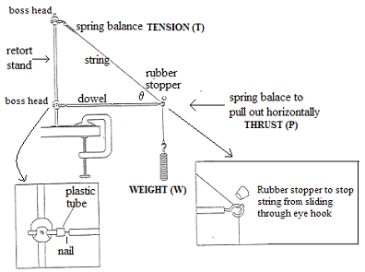

a. The student uses a 300 g mass. If the angle between the dowel and the string (θ) is 60º, what value could be expected for the tension (T) in the string.

*✓*

*✓*

*✓*

*(3 Marks)*

b. Estimate the value the student will obtain for Thrust (P)

*✓*

*✓*

*(2 Marks)*

b. What will happen to the tension (T) if the angle is decreased? Why?

The tension will increase, *✓* because the vertical component decreases with angle, but as it still must balance with the mass the Tension must increase. *✓*

Or

$T=\frac{mg}{sinθ}$ as $θ$ decreases, so does $\sin{θ }$, so T increases *✓*

*(2 Marks)*

**Question Three (7 Marks)**

An experiment in projectile motion is set up as follows:

Photogates 10cm apart

Marble

TABLE (90 cm high)

a. If the time for the ball to travel between the photogates is 0.135 seconds, what horizontal distance from the edge of the table should the ball land on the floor?

*(5 Marks)*

b. In class when we did this experiment we laid a metre rule on the ground and observed where the ball landed. However, it was difficult to be accurate as the marble was moving quickly and bounced. How could we improve the accuracy of this measurement?

*(2 Marks)*

**Question Four (8 Marks)**

**1a).** A 1 metre ruler is balanced horizontally on a pivot created by a pin through a hole in the ruler at the 50 cm mark. If 200g is hung at the 20cm mark, as shown

20 cm mark

100 cm mark

1 metre rule

0 cm mark

Pivot at 50cm mark

At what mark would you have to hang a 250g mass to balance it? (Your answer of course will be greater than 50cm and less than 100cm – show working).

*✓*

*✓*

*At the 74 cm mark. ✓*

*(3 Marks)*

b) The following experiment was set up to investigate an alternative way of weighing a 1 metre rule:

Pivot at 80cm mark

100 cm mark

1 metre rule

0 cm mark

The ruler had a hole in it at the 80cm mark. This was used as the pivot. It was found that if a 50g mass was hung at the 96cm mark, the ruler balanced. What is the mass of the ruler in grams?

$\sum{ACWM= \sum{CWM}}$

*m(0.3) = 0.05(0.16) ✓*

*m= 0.027kg ✓*

*The ruler has mass 27g. ✓*

*(3 Marks)*

1. For the above experiments to work, the ruler must satisfy two assumptions. What are they?
2. *The centre of mass is at the 50cm mark. ✓*
3. *The ruler is uniform. ✓*

*(2 Marks)*

**Question Five (8 Marks)**

1. This device is a simple DC motor. Give three ways in which you could increase the speed of this motor.

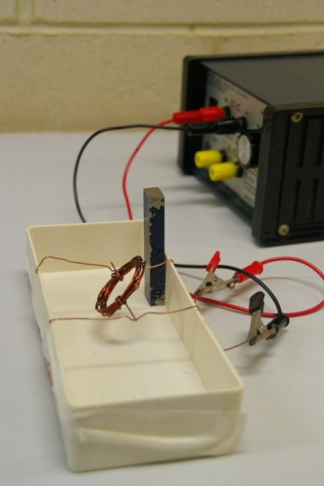

i)_______________________________________________________________

ii)_______________________________________________________________

iii)_______________________________________________________________

Or similar

*(3 marks)*

b. To get around the problem of building a commutator, the students sanded only half of the lacquer off 1 tail of the loop instead of all of the lacquer as they did on the other tail. How does this replace a commutator?

*The tail which is half lacquered effectively turns the motor on and off ✓, allowing it to perform a full rotation. ✓*

*(2 marks)*

c. Some students noticed that their motor worked better when the bar magnet was upright (as shown in photograph) while others found their motor ran better if the bar magnet was lying down. Why?

*It depends which half of the lacquer the student sanded off. ✓ If the coil was vertical when the magnet was switched off, a horizontal magnet would work better ✓, but if the coil was horizontal when it turned off the vertical magnet works better. ✓*

*(3 marks)*

**Question Six (2 Marks)**For the following diagram showing a current carrying wire, draw in a magnaprobe magnet:

in its correct orientation next to each of the two spots marked with an “◊”.

S

N

◊

◊ *(2 Marks)*

**Question Seven (9 Marks )**

The force between two bar magnets is measured by placing one magnet on a set of electronic scales and then changing the distance between it and a second magnet and recording the reading on the scales.

Electronic Balance

When doing this a student was able to produce the following graphs:

a. This experiment could be done by putting like poles or unlike poles together. Which would give the best set of data? Why?

*(2 Marks)*

b. The student did the experiment by putting like poles together, but nowhere in their calculations did they mention the weight of the magnet on the scales. Have they made an error?

*(2 Marks)*

c. What does the second graph tell you about the relationship between the force and the inverse distance squared?

*(1 Mark)*

b. The student has forgotten to put units for inverse distance squared $\left(\frac{1}{d^{2}}\right)$. What should the units be?

*(1 Mark)*

c. If $F=\frac{k}{r^{2}}$, estimate k from the graphs (show working)

*(3 Marks)*